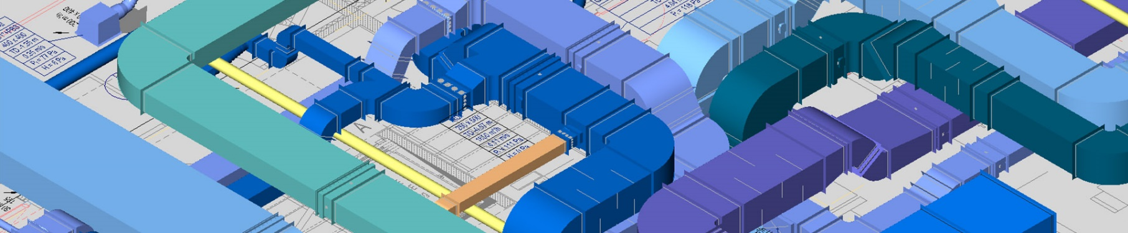
The ultimate 3D CAD & BIM platform
for HVAC industry professionals

Congratulation!

To take free training* fill out and sent the registration form:

REGISTRATION FORM

Name:
Last Name
Company Name:
E-mail:
Mobile:
Address:
CAD environment:
Date and time:

mail: info@fluid-desk.com
skype: eg-fluid-desk
What’s up and phone: +48 609 85 98 62
FB: FLUID DESK
Twitter: https://twitter.com/fluid_desk

Do not forget to add “ULTIMATE VENTPACK – FREE TRAINING” in subject of your e-mail or massage.

Subscribe also to the FLUID DESK You Tube channel and get easy access to tutorials videos

*The promotion applies to licensees with mobile phone number registered in the territory of USA and with a domicile address or registered office in the USA.

