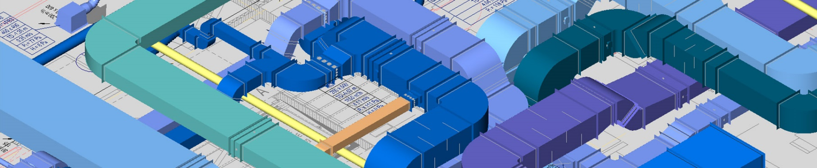
The ultimate 3D CAD & BIM platform
for HVAC industry professionals

Congratulation!

Please send us the registration form to the e-mail address: info@fluid-desk.com to get a six months license for free of the most productive CAD & BIM software for HVAC systems.

Do not forget to add in subject of your e-mail with Registration form:

“ULTIMATE VENTPACK – REGISTRATION FORM – SIX MONTHS FREE LICENSE”

REGISTRATION FORM

Name:
Last Name
Company Name:
E-mail:
Mobile*
Address*
CAD environment:

* The promotion applies to licensees with mobile phone number registered in the territory of USA.
** The promotion applies to licensees with a domicile address or registered office in the USA.

